Lab: Connecting the Database
Goal: Learn how to properly use an external data source, and handle errors in an elegant manner.

Add Entity Framework Core support
Entity Framework Core is an ORM (Object Relational Mapper) framework by Microsoft.
It allows you to link you data model (entities) to the underlying schema of your data source (e.g. SQL tables), so you’re not bothered with the DSL syntax to query this data store (e.g. Transact SQL for Microsoft SQL Server).
In this lab, we’ll use an In Memory datastore, so there is no need to install or use an existing database. Be aware that all the data changes we do while running the application are done in memory and they will be lost when we stop and restart the application.
This makes In Memory datastores less useful for production scenarios, that require data durability!
Steps:
- Open the Nuget packet manager
(in the Solution Explorer, right click on “Dependencies” and select “Manage Nuget Packges…”
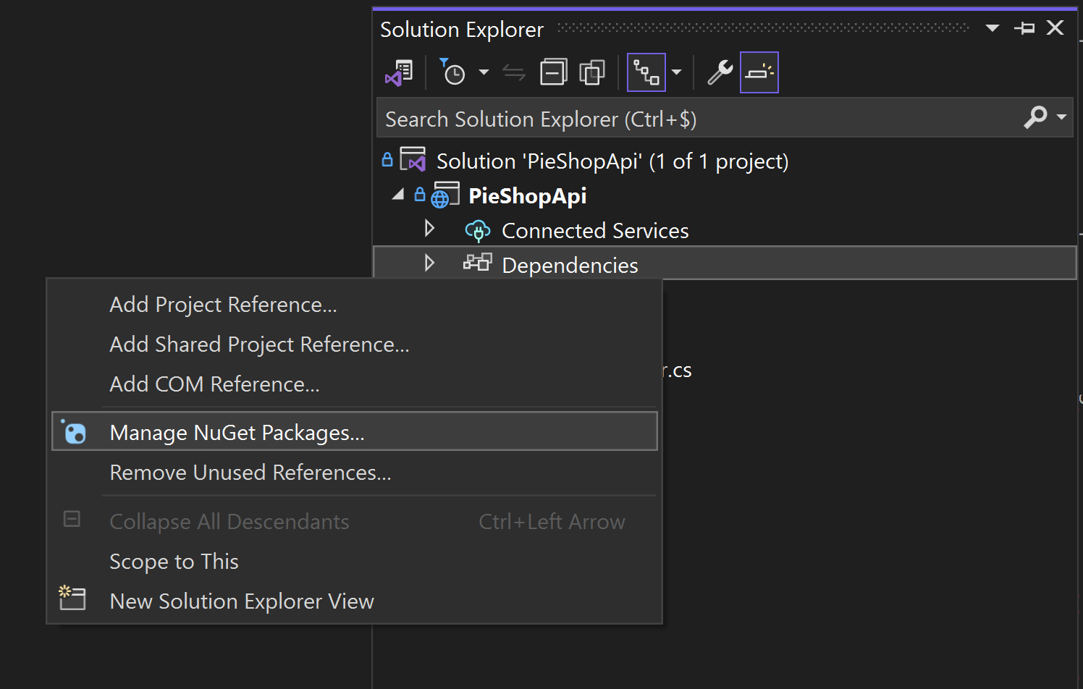
- Go to the Browse tab and search for “Microsoft.EntityFrameworkCore.InMemory” and click “Install”
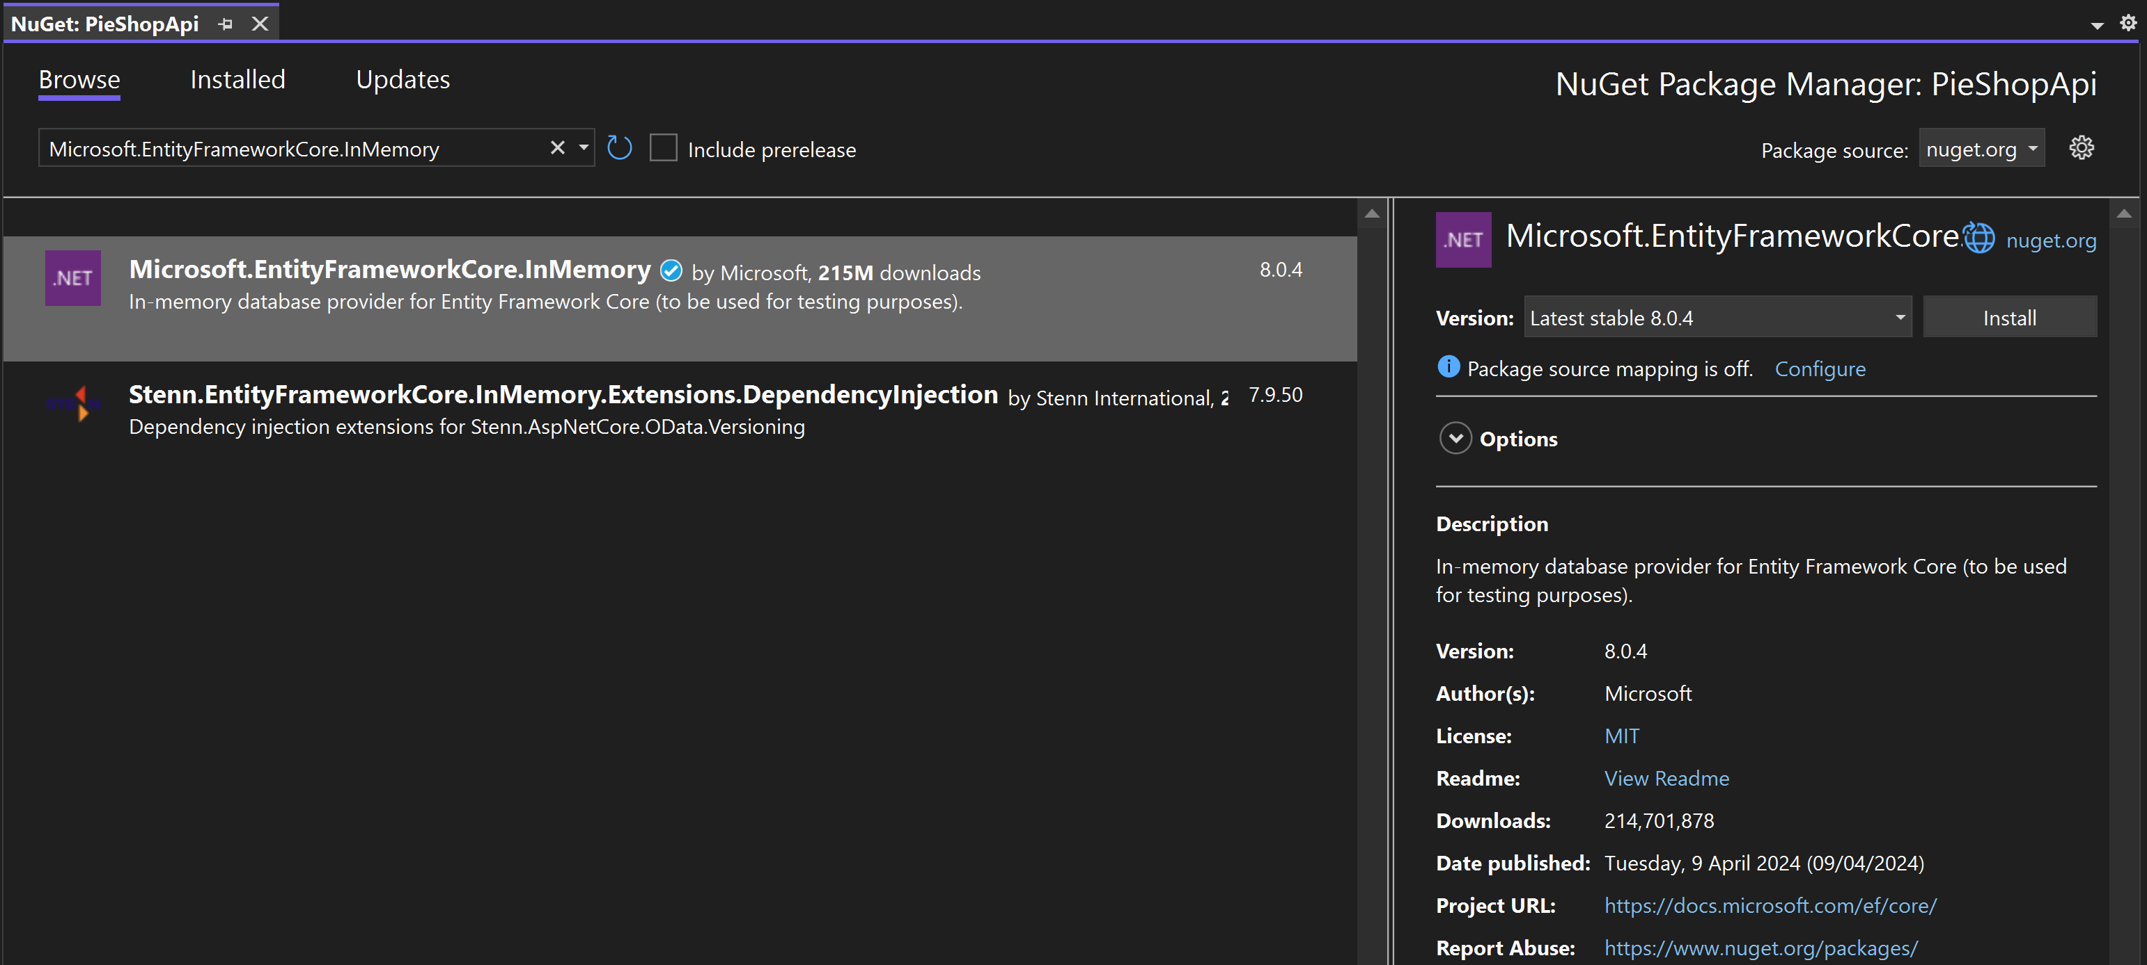
To use Entity Framework Core, we need to create DbContext, which we can use to configure our ORM and use its methods to interact with our data store.
- In our project, add a folder named “Persistence”
(Right click on the project Add New Folder)
- In the “Persistence” folder, add a class named “PieShopDbContext”
(Right click on the folder Add Class…)
- In the class
  - add a using statement for “Microsoft.EntityFrameworkCore”
  - inherit from “DbContext”
  - implement the base constructor
using Microsoft.EntityFrameworkCore;

namespace PieShopApi.Persistence
{
public class PieShopDbContext: DbContext
{
public PieShopDbContext(DbContextOptions<PieShopDbContext> options) : base(options)
{
}
}
}
- We want to map our Pie class to the datastore, so we add a “DbSet” of type “Pie” as a public property to our context.
(Don’t forget to include a using statement for “PieShopAPi.Models”, which contains our Pie class)
public class PieShopDbContext: DbContext
{
public PieShopDbContext(DbContextOptions<PieShopDbContext> options): base(options)
{
}

public DbSet<Pie> Pies { get; set; }
}

- To have some data in our database for testing purposes, we can override the “OnModelCreating” method of the DbContext base class and seed in some test data.
public class PieShopDbContext : DbContext
{
public PieShopDbContext(DbContextOptions<PieShopDbContext> options) : base(options)
{
}

public DbSet<Pie> Pies { get; set; }

override protected void OnModelCreating(ModelBuilder modelBuilder)
{
modelBuilder.Entity<Pie>().HasData(
new Pie { Id = 1, Name = "Apple Pie", Description = "Tasty" },
new Pie { Id = 2, Name = "Cherry Pie", Description = "Yummy" },
new Pie { Id = 3, Name = "Pumpkin Pie", Description = "Delicious" },
new Pie { Id = 4, Name = "Blueberry Pie", Description = "Scrumptious" },
new Pie { Id = 5, Name = "Peach Pie", Description = "Succulent" },
new Pie { Id = 6, Name = "Pecan Pie", Description = "Rich" },
new Pie { Id = 7, Name = "Lemon Meringue Pie", Description = "Zesty" },
new Pie { Id = 8, Name = "Key Lime Pie", Description = "Tangy" },
new Pie { Id = 9, Name = "Banana Cream Pie", Description = "Creamy" },
new Pie { Id = 10, Name = "Coconut Cream Pie", Description = "Tropical" },
new Pie { Id = 11, Name = "Rhubarb Pie", Description = "Tart" },
new Pie { Id = 12, Name = "Sweet Potato Pie", Description = "Velvety" },
new Pie { Id = 13, Name = "Blackberry Pie", Description = "Juicy" },
new Pie { Id = 14, Name = "Bumbleberry Pie", Description = "Berry-licious" },
new Pie { Id = 15, Name = "Pear Pie", Description = "Sweet" },
new Pie { Id = 16, Name = "Raspberry Pie", Description = "Tangy" },
new Pie { Id = 17, Name = "Strawberry Rhubarb Pie", Description = "Refreshing" },
new Pie { Id = 18, Name = "Mississippi Mud Pie", Description = "Decadent" },
new Pie { Id = 19, Name = "Salted Caramel Pie", Description = "Savory-sweet" },
new Pie { Id = 20, Name = "Mince Pie", Description = "Spiced" },
new Pie { Id = 21, Name = "Custard Pie", Description = "Smooth" },
new Pie { Id = 22, Name = "French Silk Pie", Description = "Luxurious" },
new Pie { Id = 23, Name = "Grasshopper Pie", Description = "Minty" },
new Pie { Id = 24, Name = "S'mores Pie", Description = "Toasty" },
new Pie { Id = 25, Name = "Margarita Pie", Description = "Zingy" },
new Pie { Id = 26, Name = "Mud Pie", Description = "Dense" },
new Pie { Id = 27, Name = "Oatmeal Pie", Description = "Hearty" },
new Pie { Id = 28, Name = "Peanut Butter Pie", Description = "Rich" },
new Pie { Id = 29, Name = "Butterscotch Pie", Description = "Buttery" },
new Pie { Id = 30, Name = "Chess Pie", Description = "Classic" },
new Pie { Id = 31, Name = "Almond Pie", Description = "Nutty" },
new Pie { Id = 32, Name = "Caramel Apple Pie", Description = "Sticky-sweet" },
new Pie { Id = 33, Name = "Maple Pie", Description = "Syrupy" },
new Pie { Id = 34, Name = "Orange Marmalade Pie", Description = "Bitter-sweet" },
new Pie { Id = 35, Name = "Fig Pie", Description = "Jammy" },
new Pie { Id = 36, Name = "Chocolate Peanut Butter Pie", Description = "Sinful" },
new Pie { Id = 37, Name = "Lime Pie", Description = "Citrusy" },
new Pie { Id = 38, Name = "Vanilla Bean Pie", Description = "Aromatic" },
new Pie { Id = 39, Name = "Mixed Berry Pie", Description = "Bursting with berries" },
new Pie { Id = 40, Name = "Espresso Pie", Description = "Coffee-flavored" },
new Pie { Id = 41, Name = "Spiced Pear Pie", Description = "Warm" },
new Pie { Id = 42, Name = "Toffee Pie", Description = "Buttery-caramel" },
new Pie { Id = 43, Name = "Plum Pie", Description = "Tart-sweet" },
new Pie { Id = 44, Name = "Mango Pie", Description = "Exotic" },
new Pie { Id = 45, Name = "Blackcurrant Pie", Description = "Intense" },
new Pie { Id = 46, Name = "Nectarine Pie", Description = "Summery" },
new Pie { Id = 47, Name = "Macadamia Nut Pie", Description = "Crunchy" },
new Pie { Id = 48, Name = "Cranberry Pie", Description = "Tangy" },
new Pie { Id = 49, Name = "White Chocolate Raspberry Pie", Description = "Velvety-rich" },
new Pie { Id = 50, Name = "Apricot Pie", Description = "Honeyed" }
);

base.OnModelCreating(modelBuilder);

}
}

We need to register our DbContext in the DI (Dependency Injection) container and tell it how it needs to be configured.
- In the program.cs file register the DbContext, configure it to use an in memory database and log the query output to the console window.
(don’t forget the using statement for “PieShopApi.Persistence”)
builder.Services.AddDbContext<PieShopDbContext>(options =>
options.UseInMemoryDatabase("PieShopDb")
.LogTo(Console.WriteLine));
- Near the bottom of the program.cs file, just before app.run(), add the code that will make sure we freshly seed the database on every run.
! Don’t use this in production !
using (var context = new PieShopDbContext(builder.Services.BuildServiceProvider()
.GetRequiredService<DbContextOptions<PieShopDbContext>>()))
{
context.Database.EnsureDeleted();
context.Database.EnsureCreated();
}

app.Run();

Add a Repository class
Adding a generic repository class is very useful to standardize the way we access our data. This is even more true in Web API scenarios where the data model resembles the endpoint structure.
Steps:
Let’s start by defining the generic interface we want our repository to implement.
We’ll use this interface later on, to register the actual implementation.
- Create a new interface called “IAsyncRepository” in the “Persistence” folder
(right click the folder Add Class…)
public interface IAsyncRepository<T> where T : class
{
Task<T?> GetByIdAsync(int id);
Task<IReadOnlyList<T>> ListAllAsync();
Task<IReadOnlyList<T>> GetPagedReponseAsync(int page, int size);
Task<T> AddAsync(T entity);
Task UpdateAsync(T entity);
Task DeleteAsync(T entity);
}
- In the same folder, create a class for the generic implementation called “RepositoryBase”
(don’t forget to include a using statement for Microsoft.EntityFrameworkCore)
public class RepositoryBase<T> : IAsyncRepository<T> where T : class
{
protected readonly PieShopDbContext _dbContext;

protected RepositoryBase(PieShopDbContext dbContext)
{
_dbContext = dbContext;
}

public virtual async Task<T?> GetByIdAsync(int id)
{
T? t = await _dbContext.Set<T>().FindAsync(id);
return t;
}

public async Task<IReadOnlyList<T>> ListAllAsync()
{
return await _dbContext.Set<T>().ToListAsync();
}

public async virtual Task<IReadOnlyList<T>> GetPagedReponseAsync(int page, int size)
{
return await _dbContext.Set<T>().Skip((page - 1) * size).Take(size).AsNoTracking().ToListAsync();
}

public async Task<T> AddAsync(T entity)
{
await _dbContext.Set<T>().AddAsync(entity);
await _dbContext.SaveChangesAsync();

return entity;
}

public async Task UpdateAsync(T entity)
{
_dbContext.Entry(entity).State = EntityState.Modified;
await _dbContext.SaveChangesAsync();
}

public async Task DeleteAsync(T entity)
{
_dbContext.Set<T>().Remove(entity);
await _dbContext.SaveChangesAsync();
}
}
- Create a concrete implementation called “PieRepository”, which is an implementation of RepositoryBase of type “Pie”
public class PieRepository : RepositoryBase<Pie>
{
public PieRepository(PieShopDbContext dbContext) : base(dbContext)
{
}
}
- In the program.cs file, register the PieRepository in the DI container, using a scoped lifetime
var builder = WebApplication.CreateBuilder(args);

builder.Services.AddDbContext<PieShopDbContext>(options =>
options.UseInMemoryDatabase("PieShopDb")
.LogTo(Console.WriteLine));

builder.Services.AddScoped(typeof(IAsyncRepository<Pie>), typeof(PieRepository));

builder.Services.AddControllers();

var app = builder.Build();

app.MapControllers();

using (var context = new PieShopDbContext(builder.Services.BuildServiceProvider()
.GetRequiredService<DbContextOptions<PieShopDbContext>>()))
{
context.Database.EnsureDeleted();
context.Database.EnsureCreated();
}

app.Run();

Use the Repository in the Controller
In this step we’ll replace our hard-coded PieStore with the the Repository we just created.
Steps:
- In the PieController.cs file, add a constructor to the PieController class and inject the PieRepository through the generic interface
[ApiController]
[Route("pies")]
public class PiesController : ControllerBase
{
private readonly IAsyncRepository<Pie> _pieRepository;

public PiesController(IAsyncRepository<Pie> pieRepository)
{
_pieRepository = pieRepository;
}
//...
}
- Update the GetPies method to use the injected repository.
Notice that since the repository methods are async methods, we changed the GetPies method to aync…await (Task<T> in method signature)
[HttpGet]
public async Task<JsonResult> GetPies()
{
return new JsonResult(await _pieRepository.ListAllAsync());
}
- Use the PieShopApi.http file to test the GetPies method and verify it works
GET {{PieShopApi_HostAddress}}/pies
- Update the GetPieById method and test in the same way
[HttpGet]
[Route("{id:int}")]
public async Task<Pie> GetPie(int id)
{
return await _pieRepository.GetByIdAsync(id);
}

The generic repository doesn’t support searching by name, which is needed by our SearchPie method of our PieController.
We have 2 options to solve this:
- We extend the generic interface, which would require all future Entities to have a name property NOK
- We extend our concrete PieRepository, so that only that repository is impacted OK
- Create an IPieRepository interface
public interface IPieRepository : IAsyncRepository<Pie>
{
Task<Pie?> GetByPartialNameAsync(string name);
}
- Implement the interface in the PieRepository
public class PieRepository : RepositoryBase<Pie>, IPieRepository
{
public PieRepository(PieShopDbContext dbContext) : base(dbContext)
{
}

public async Task<Pie?> GetByPartialNameAsync(string name)
{
Pie? pie = await _dbContext.Pies.Where(p => p.Name.Contains(name)).FirstOrDefaultAsync();

return pie;
}
}
- Change the DI service registration
builder.Services.AddScoped(typeof(IPieRepository), typeof(PieRepository));
- Change the injected interface in the PieController
[ApiController]
[Route("pies")]
public class PiesController : ControllerBase
{
private readonly IPieRepository _pieRepository;

public PiesController(IPieRepository pieRepository)
{
_pieRepository = pieRepository;
}
//...
}
- Implement the SearchPie method and test it using the .http file
[HttpGet]
[Route("search")]
public async Task<Pie> SearchPie(string name)
{
return await _pieRepository.GetByPartialNameAsync(name);
}
- Remove (or comment out) the PieStore class, as we don’t need it anymore

Implement (simple) paging
In this part, we’ll change our “GetPies” method in our PiesController, so that we can fetch paged responses. Paging helps in keeping our responses (for big data sets) performant.
Luckily our generic repository already has a method for this: GetPagedResponseAsync(int page, int size)
Steps:
- In the PiesController, change the method signature of the GetPies method, so that it receives 2 optional parameters: page (type int) and size (type int).
We make the parameters optional so that we keep support for unpaged requests.
In the implementation, we check if the parameters are provided, so we can decide whether or not to return a paged result.
[HttpGet]
public async Task<JsonResult> GetPies(int? size, int? page)
{
if (size.HasValue && size.Value > 0 && (page.HasValue && page > 0 || !page.HasValue))
{
return new JsonResult(await _pieRepository.GetPagedReponseAsync(page ?? 1, size.Value));
}

return new JsonResult(await _pieRepository.ListAllAsync());
}
- Run the application (F5) and use the PieShopApi.http file to test:
  - Without paging:
GET {{PieShopApi_HostAddress}}/pies
  - With paging:
GET {{PieShopApi_HostAddress}}/Pies?page=1&size=5
- Have a look at the generate query (in the console) for the paged request.
Notice the query takes into account the paging, instead of fetching the complete list before doing the paging.
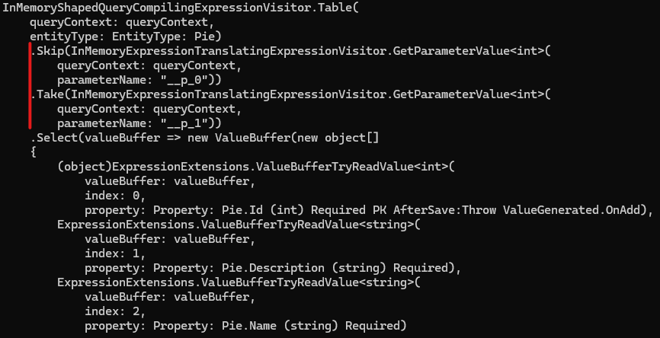
We accomplish this with the code in our generic repository, by calling ToListAsync() after Skip() and Take(). This is called “Deferred execution”.
public async virtual Task<IReadOnlyList<T>> GetPagedReponseAsync(int page, int size)
{
return await _dbContext.Set<T>()
.Skip((page - 1) * size)
.Take(size)
.AsNoTracking()
.ToListAsync();
}

Handling Exceptions
When running your application, sometimes unexpected exceptions occur.
e.g. the database server is unreachable or a coding bug was introduced.
In this part we’ll cover how to handle this
Steps:
To simulate a unhandled Exception, we’ll create a new method in our controller that throws an NotImplementedException().
- Add a method named FilterPie, that throws an Exception when executed
[HttpGet]
[Route("filter")]
public async Task<ActionResult<Pie>> FilterPie()
{
throw new NotImplementedException();
}
- Test the newly create method using our .http file
GET {{PieShopApi_HostAddress}}/Pies/filter
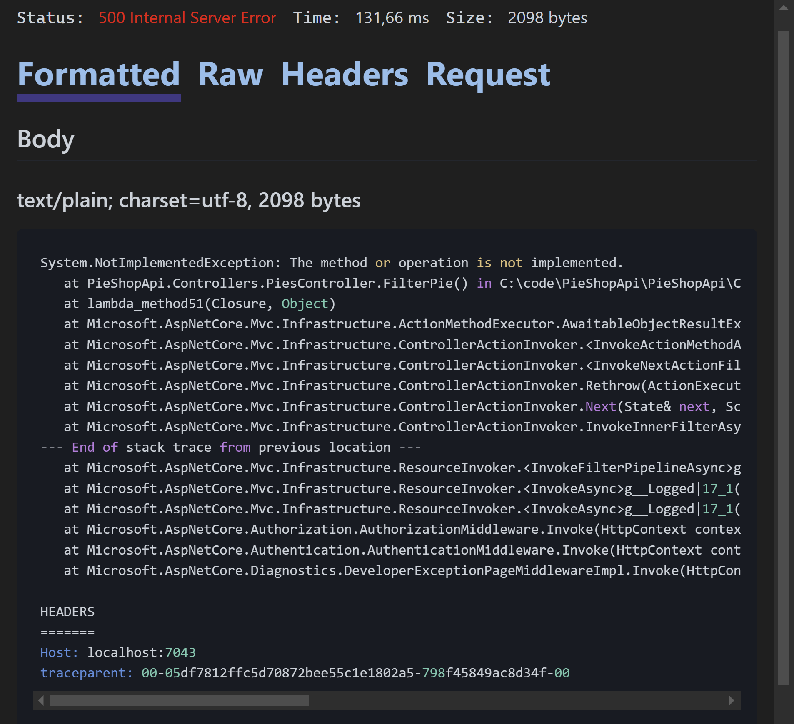
Notice we get 500-Internal Server Error response, including a stack trace
- Try the URL in a browser, by navigating to https://localhost:7043/pies/filter
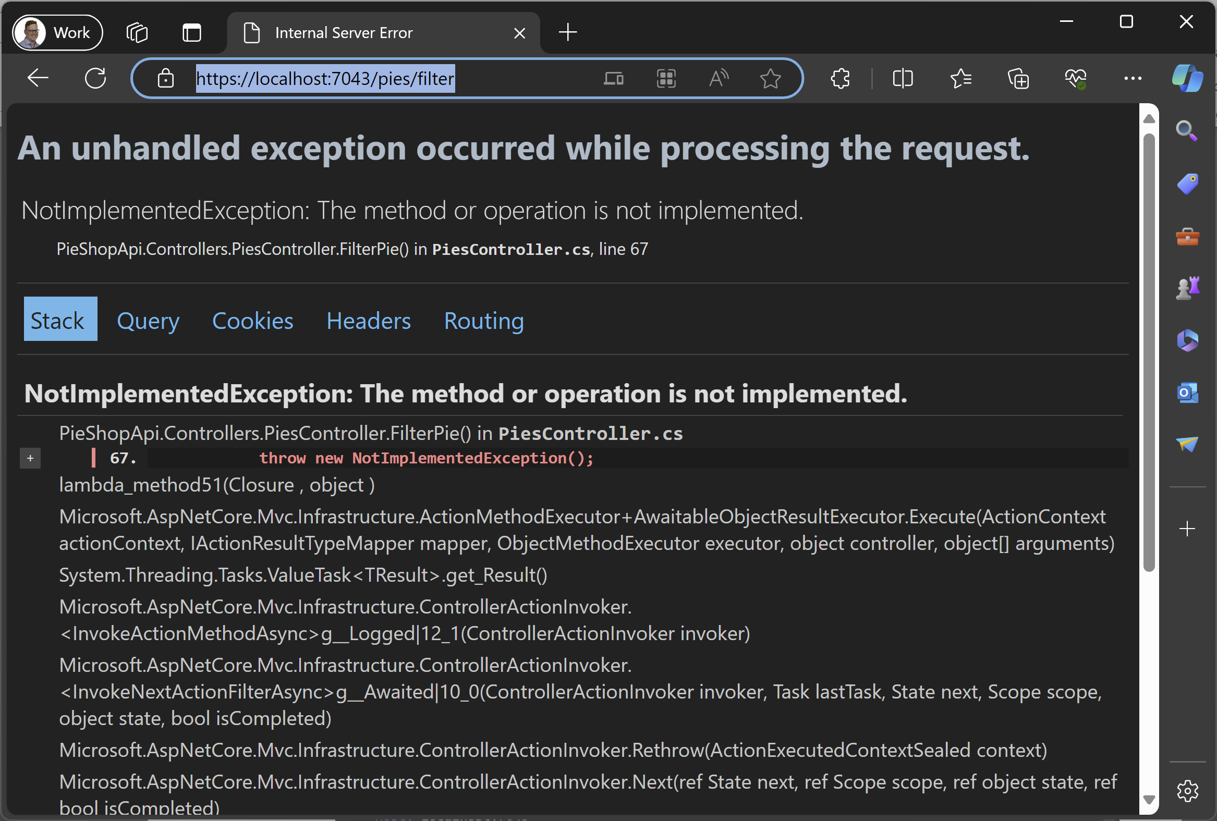
Notice we get an Exception page, including the stack trace
Showing stack trace information is useful in development scenarios, but in production, it reveals too much information about our code that might be misused by hackers.
- Open the Properties/launchSettings.json file, look for the “https” profile and change value for “ASPNETCORE_ENVIRONMENT” to something different than “Development”
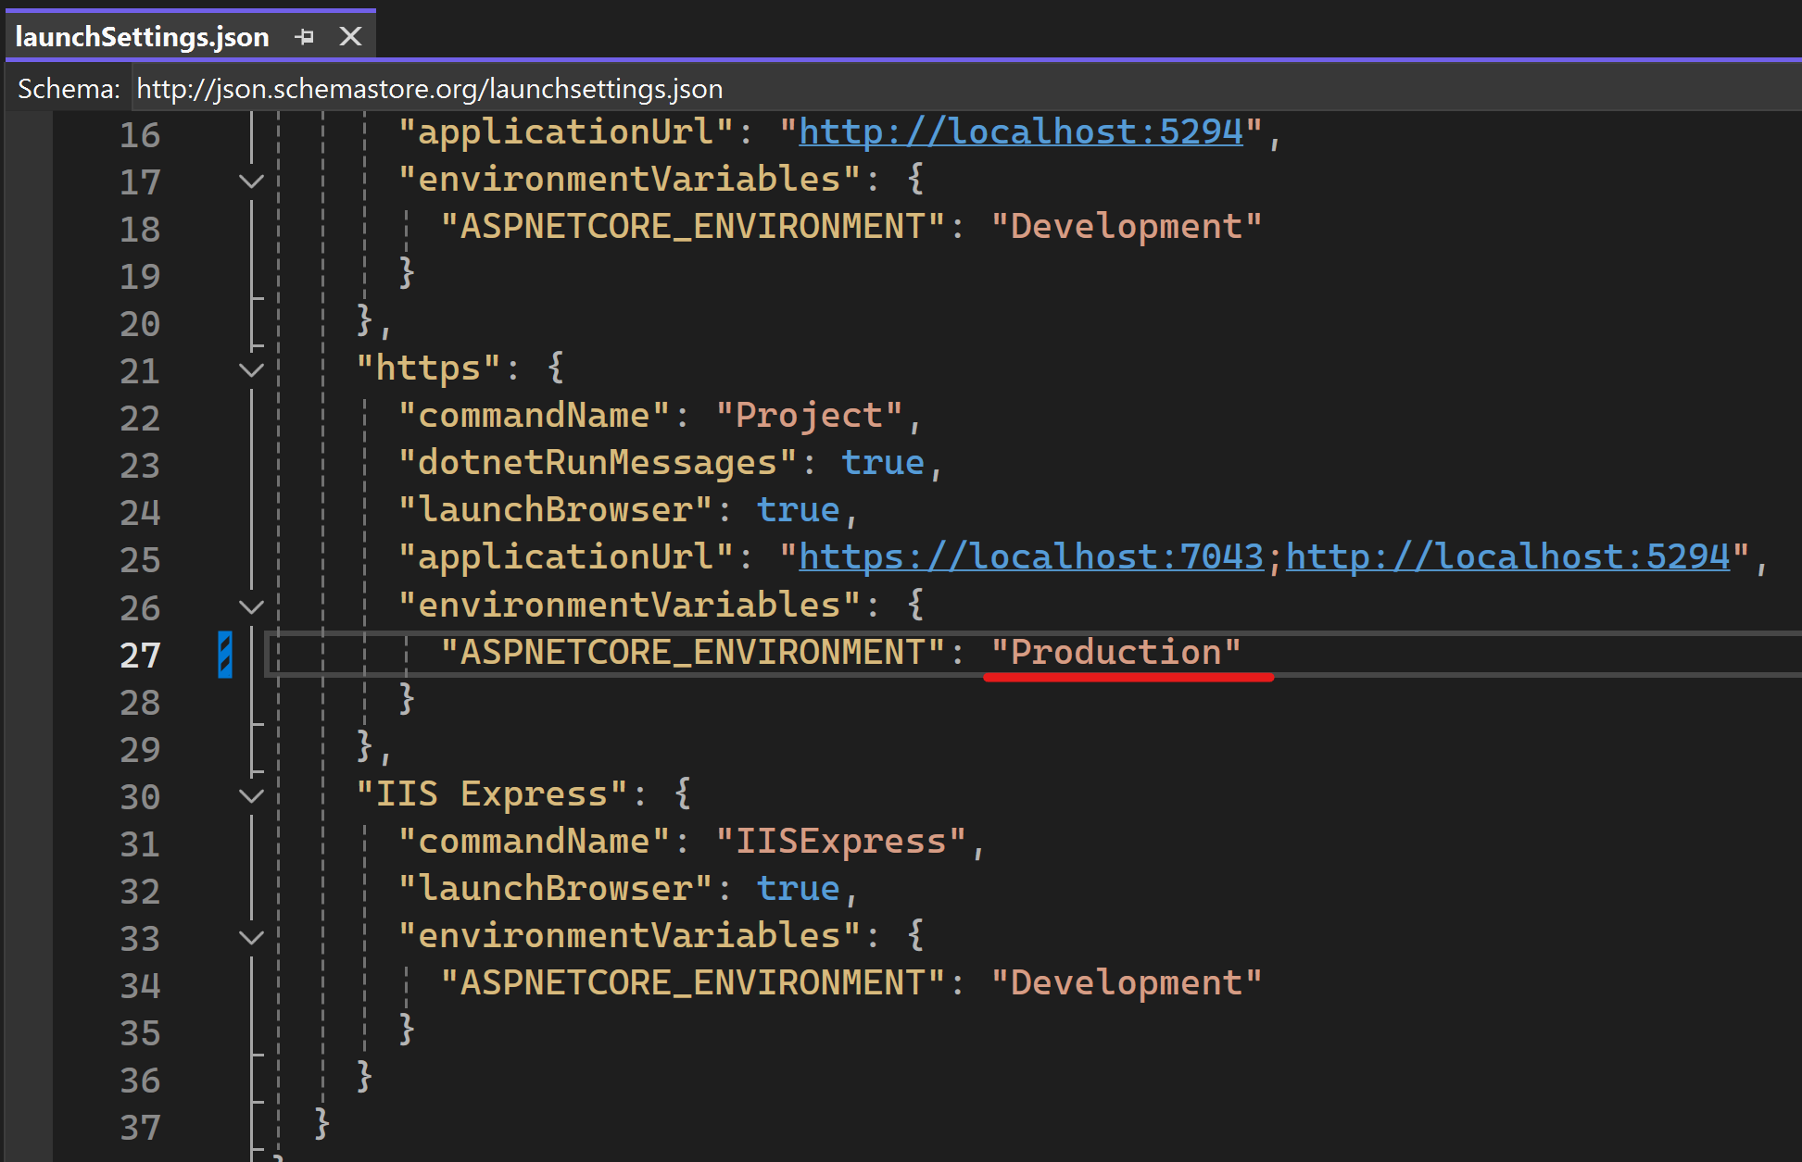
- Relaunch the application and test again using the .http file
Notice we’re not getting a stack trace anymore
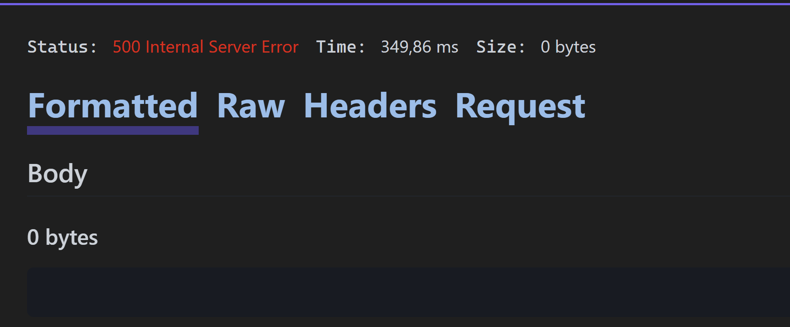
- Switch the value for “ASPNETCORE_ENVIRONMENT” back to “Development”

Return the correct HTTP status codes
Up until now, we implemented the happy path, were we assumed the consumer passed proper parameters to our endpoint.
In this part, we’ll implement alternate paths and inform the consumer with the correct status code in case of an issue
Steps:
The GetPieById method, assumes that the consumer requests an existing Id
- Test requesting an unexisting Id using the .http file
GET {{PieShopApi_HostAddress}}/pies/999

We get a 204-No Content response
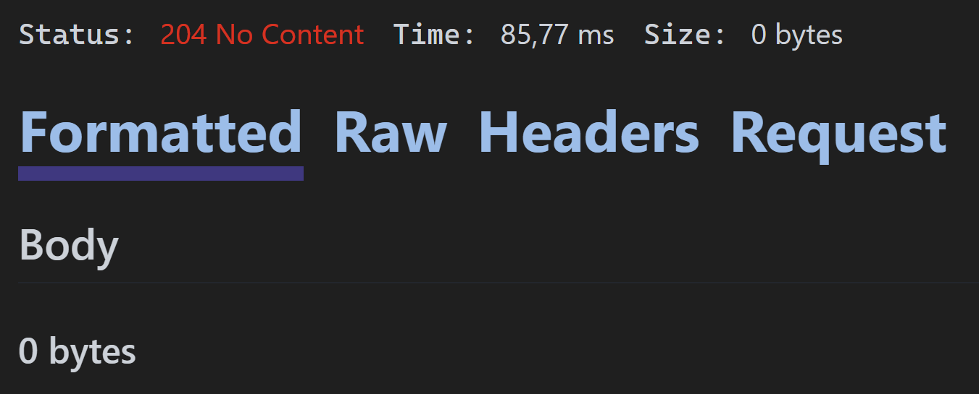
Better is to inform our consumer that the requested Id was not found, by returning a HTTP status code 404-Not Found
- Change the GetPie method to return a 404-Not Found response when the Id was not found and a 200-Ok when it was found
Notice we had to switch our method signature to return ActionResult<Pie>
[HttpGet]
[Route("{id:int}")]
public async Task<ActionResult<Pie>> GetPie(int id)
{
var pie = await _pieRepository.GetByIdAsync(id);

if(pie == null)
return NotFound();

return Ok(pie);
}
- Test again using the .http file
GET {{PieShopApi_HostAddress}}/pies/999
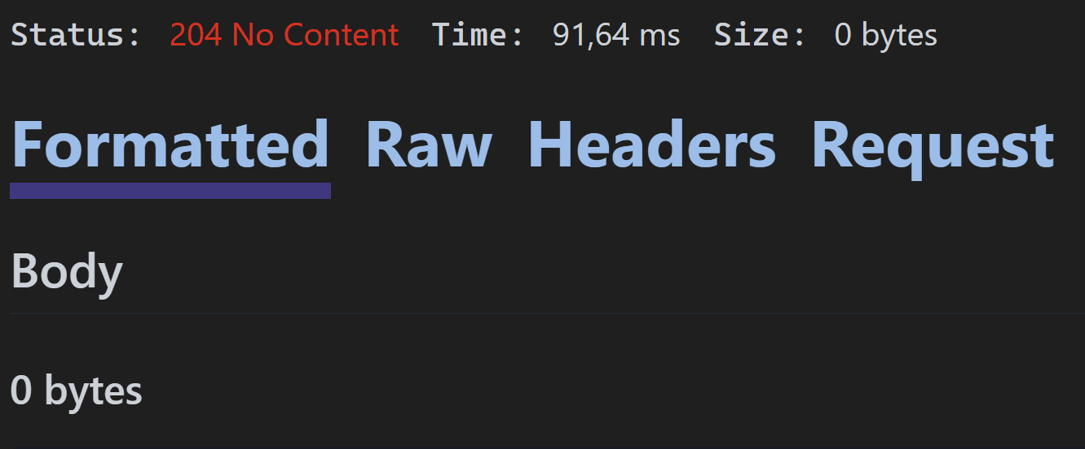
- Lets do the same for the SearchPie method and test the result
[HttpGet]
[Route("search")]
public async Task<ActionResult<Pie>> SearchPie(string name)
{
var pie = await _pieRepository.GetByPartialNameAsync(name);

if(pie == null)
return NotFound();

return Ok(pie);
}

Our paging-enabled GetPies method can also be improved.
When a consumer passes in negative values or requests too many results, we want to return a HTTP status code 400-Bad Request.
We can also include a custom message that goes with the status code, providing more info to the consumer.
- Change the GetPies method to return a bad request when the page or size values are not as expected
Notice we had to change our method signature return type from JsonResult to an ActionResult<IEnumerable<Pie>>
[HttpGet]
public async Task<ActionResult<IEnumerable<Pie>>> GetPies(int? size, int? page)
{
if ((size.HasValue && (size.Value <= 0 || size.Value > 50)) || (page.HasValue && page.Value <= 0))
{
return BadRequest(new
{
error = "Bad input!",
details = "Size, if provided, must be between 1 and 50. Page, if provided, must be greater than 0."
});
}

if (size.HasValue && size.Value > 0 && (page.HasValue && page > 0 || !page.HasValue))
{
return new JsonResult(await _pieRepository.GetPagedReponseAsync(page ?? 1, size.Value));
}

return new JsonResult(await _pieRepository.ListAllAsync());
}
- Lets test our change by requesting a page size of 500 (larger than 50), using the .http file and verify a 400-Bad Request code is returned, including the custom message
GET {{PieShopApi_HostAddress}}/Pies?page=1&size=500
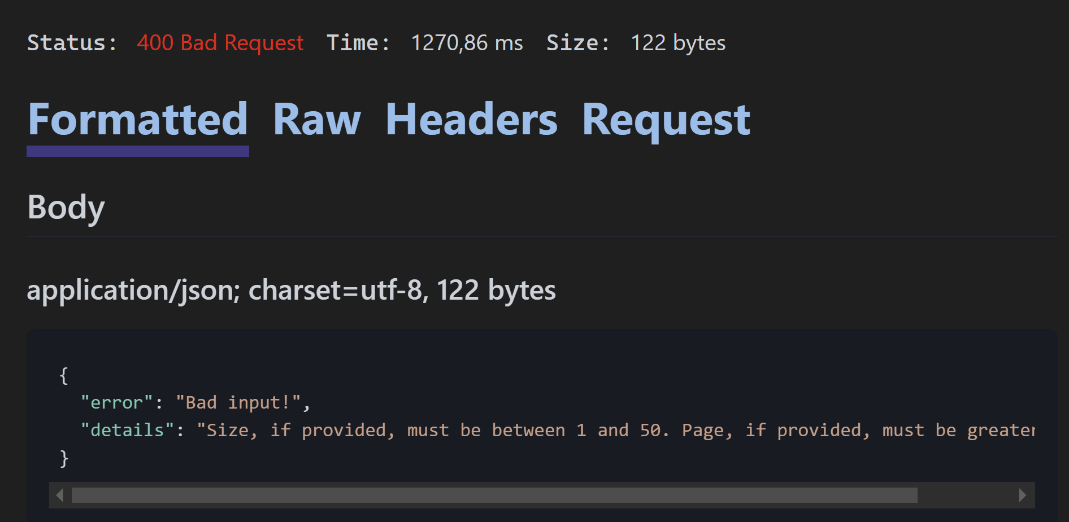

Adding Problem Details
In this section we’ll look at implementing the Problem Details standard to structure our errors.
By following a standard instead of our custom error syntax, our consumers (and their libraries) can leverage it.
Steps:
- Let’s change our GetPies method to return a Problem instead of BadRequest
[HttpGet]
public async Task<ActionResult<IEnumerable<Pie>>> GetPies(int? size, int? page)
{
if ((size.HasValue && (size.Value <= 0 || size.Value > 50)) || (page.HasValue && page.Value <= 0))
{
return Problem(
title: "Bad Input",
detail: "Size, if provided, must be between 1 and 50. Page, if provided, must be greater than 0.",
type: "Paging_Error",
statusCode: StatusCodes.Status400BadRequest
);
}

if (size.HasValue && size.Value > 0 && (page.HasValue && page > 0 || !page.HasValue))
{
return new JsonResult(await _pieRepository.GetPagedReponseAsync(page ?? 1, size.Value));
}

return new JsonResult(await _pieRepository.ListAllAsync());
}
- Test the change with the .http file
GET {{PieShopApi_HostAddress}}/Pies?page=1&size=500
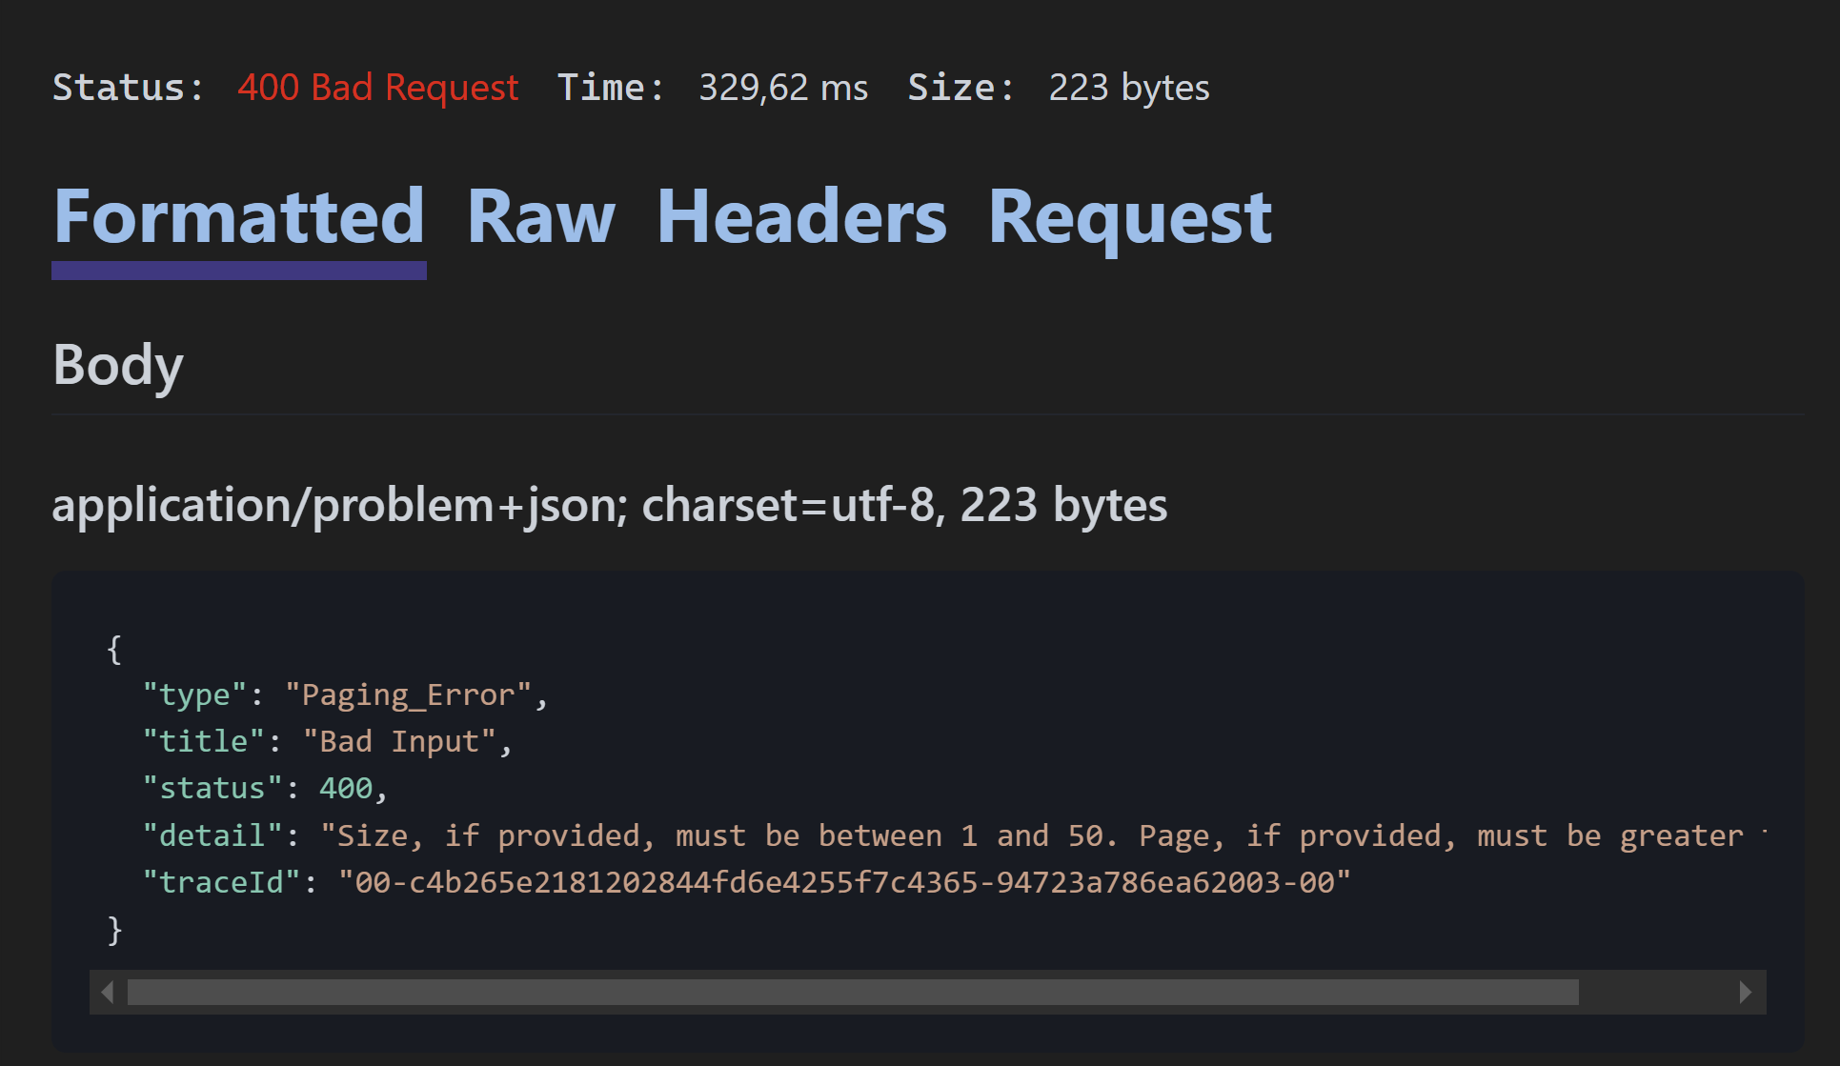
Notice the structure of our error
- In the Program.cs file, let’s change the configuration in ASP.NET Core to also include the version of our application, so that our potential consumers can log a ticket referencing it
var builder = WebApplication.CreateBuilder(args);

builder.Services.AddDbContext<PieShopDbContext>(options =>
options.UseInMemoryDatabase("PieShopDb")
.LogTo(Console.WriteLine));

builder.Services.AddScoped(typeof(IPieRepository), typeof(PieRepository));

builder.Services.AddControllers();

builder.Services.AddProblemDetails(
options =>
options.CustomizeProblemDetails = ctx =>
{
ctx.ProblemDetails.Extensions.Add("version", Assembly.GetExecutingAssembly().GetName().Version);
}
);

var app = builder.Build();

app.MapControllers();

using (var context = new PieShopDbContext(builder.Services.BuildServiceProvider()
.GetRequiredService<DbContextOptions<PieShopDbContext>>()))
{
context.Database.EnsureDeleted();
context.Database.EnsureCreated();
}

app.Run();
- When we test again using our .http file, the version is now also shown
GET {{PieShopApi_HostAddress}}/Pies?page=1&size=500
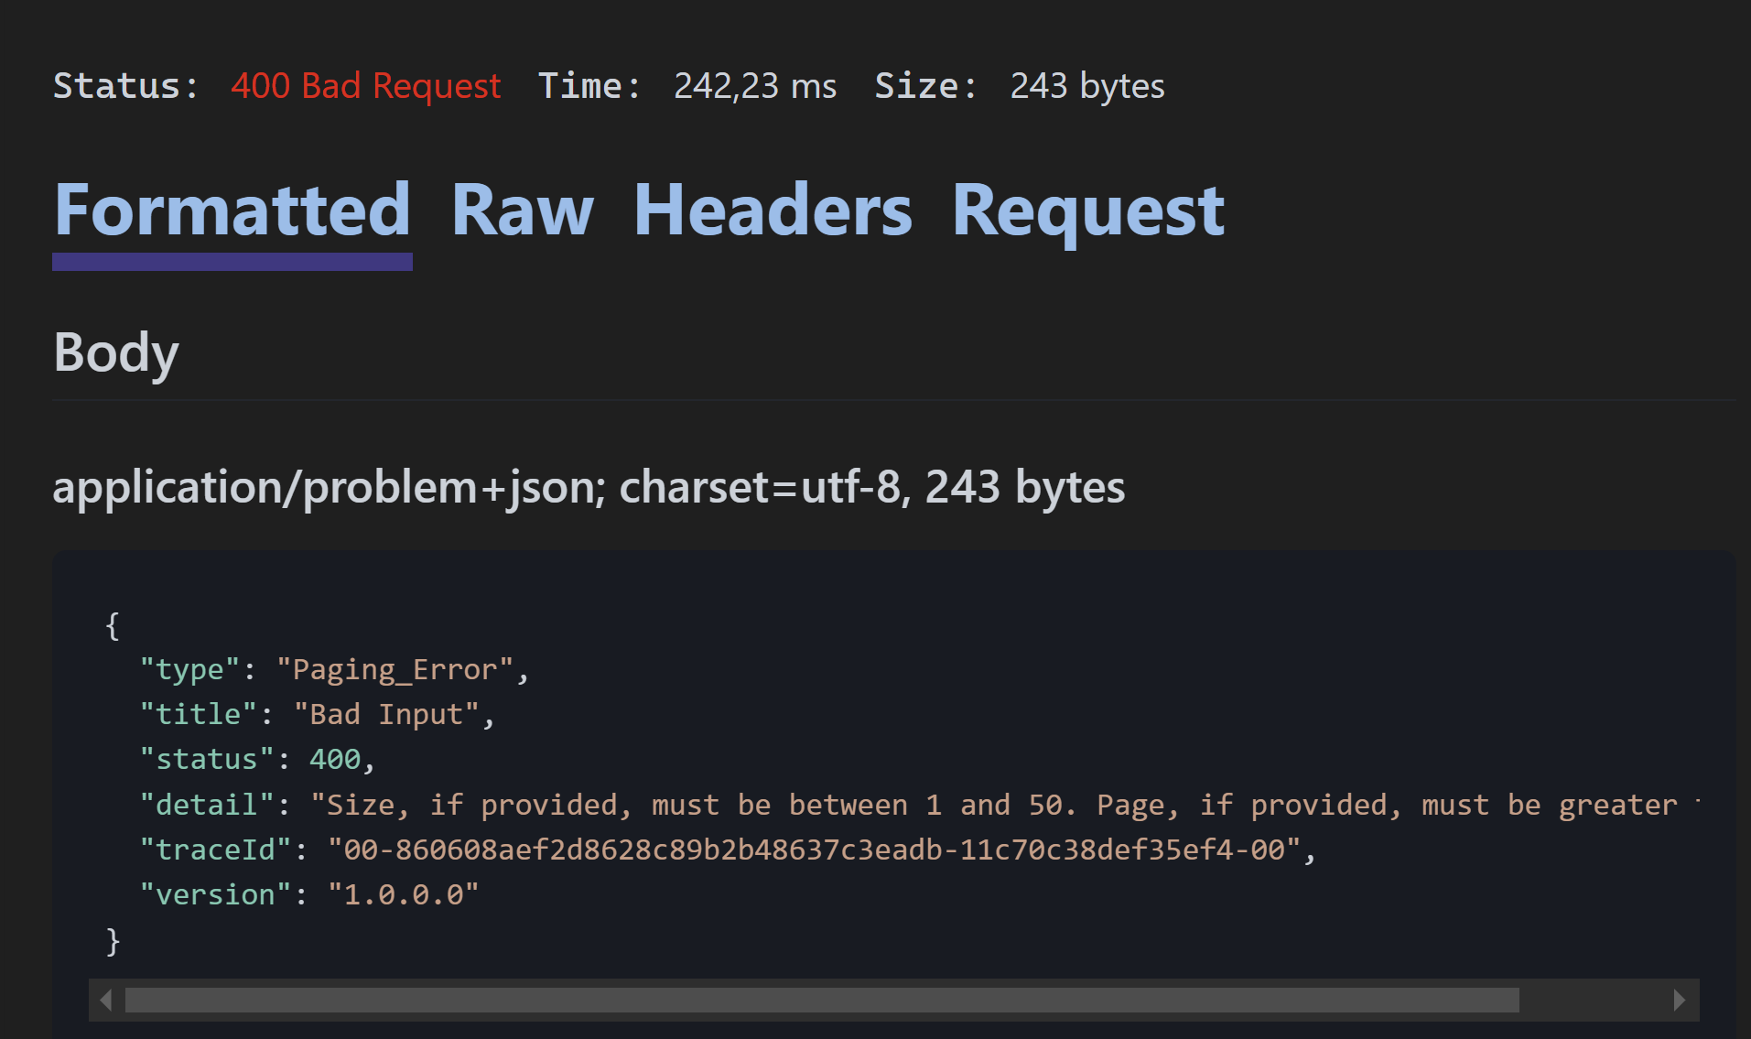
Notice “version”: “1.0.0.0”
By adding support for Problem Details in our pipeline, our Exceptions are also presented in this standard format.
Note that this only works when an ExceptionHandler is also registered:
for Development this is implicitly covered by the Developer Exception Page
for Production we need to add it explicitly: app.UseExceptionHandler();
- Test our Filter() method (which throws an NotImplementedException) using our .http file
GET {{PieShopApi_HostAddress}}/Pies/filter
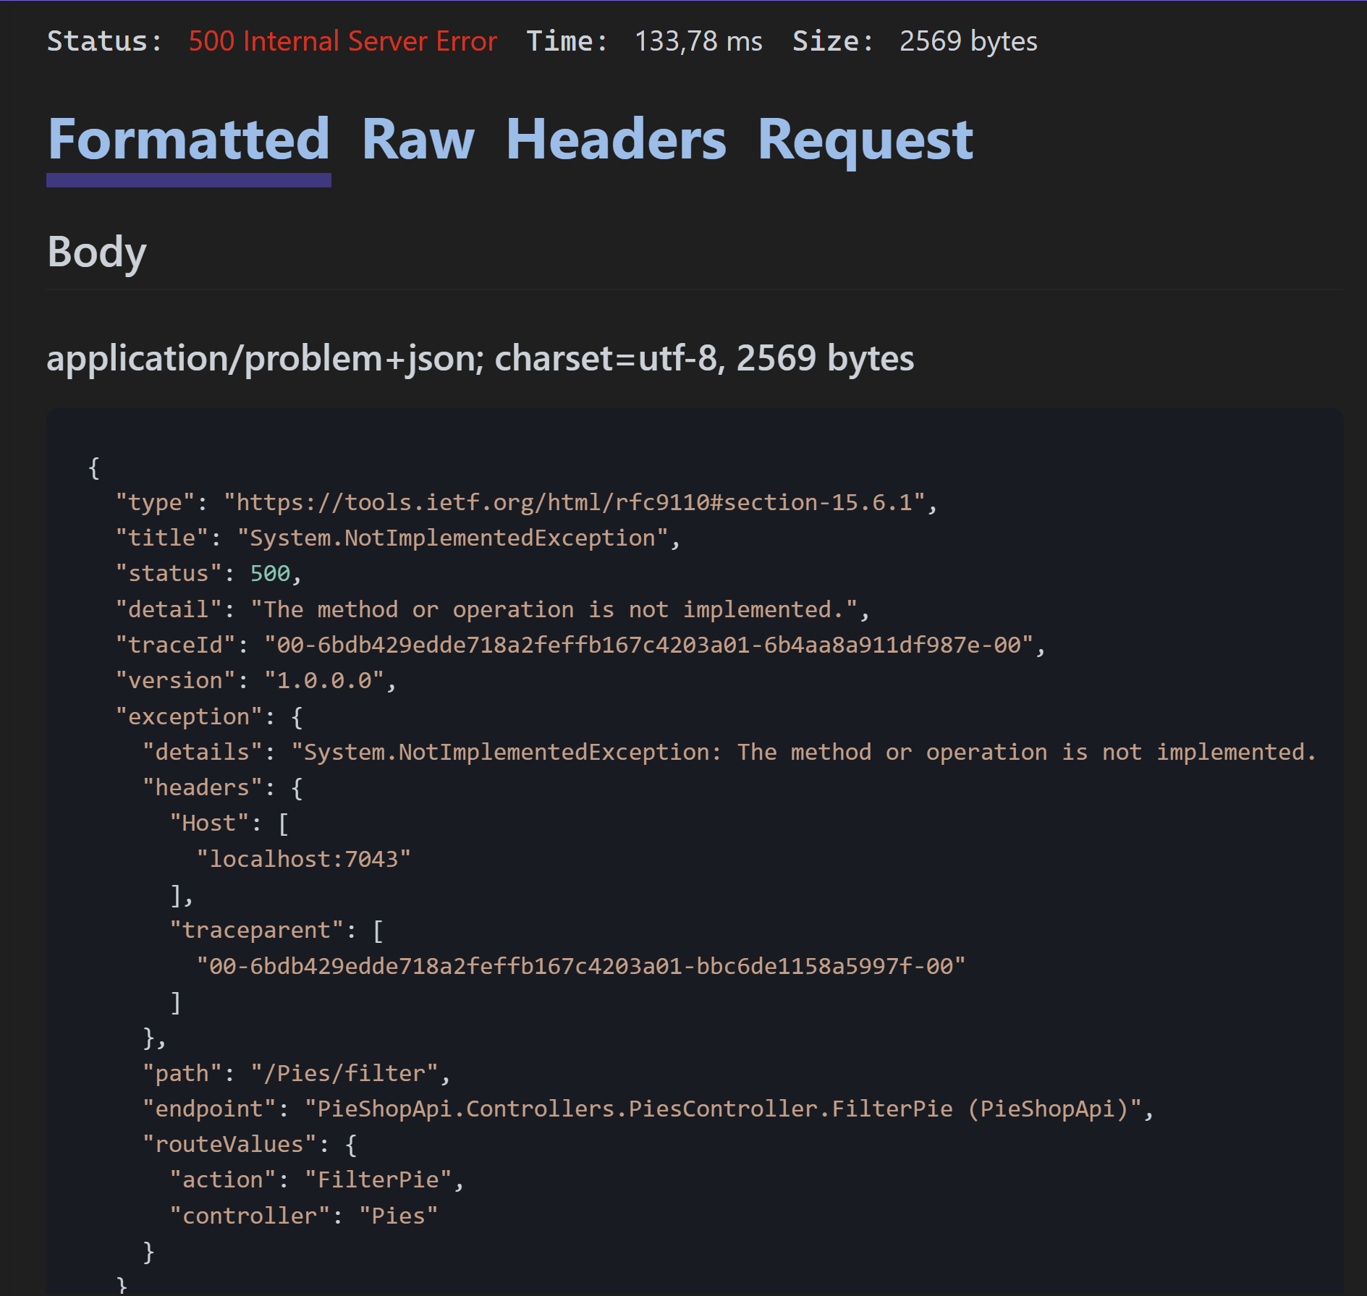
- Enable the ExceptionHandler for non-Development environments
var builder = WebApplication.CreateBuilder(args);

builder.Services.AddDbContext<PieShopDbContext>(options =>
options.UseInMemoryDatabase("PieShopDb")
.LogTo(Console.WriteLine));

builder.Services.AddScoped(typeof(IPieRepository), typeof(PieRepository));

builder.Services.AddControllers();

builder.Services.AddProblemDetails(
options =>
options.CustomizeProblemDetails = ctx =>
{
ctx.ProblemDetails.Extensions.Add("version", Assembly.GetExecutingAssembly().GetName().Version);
}
);

var app = builder.Build();

app.MapControllers();

if(!app.Environment.IsDevelopment())
{
app.UseExceptionHandler();
}

using (var context = new PieShopDbContext(builder.Services.BuildServiceProvider()
.GetRequiredService<DbContextOptions<PieShopDbContext>>()))
{
context.Database.EnsureDeleted();
context.Database.EnsureCreated();
}

app.Run();
- Change the value for “ASPNETCORE_ENVIRONMENT” again to something else than “Development” and test again using the .http file
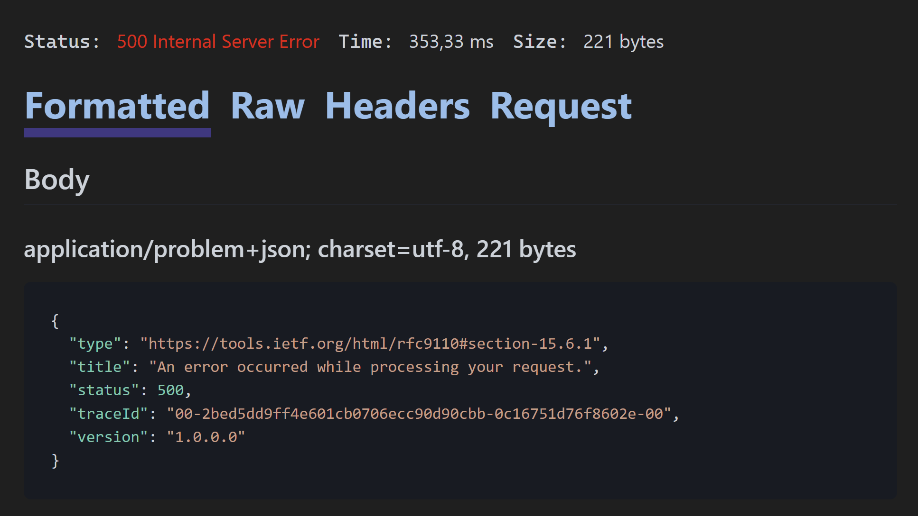
- Change the value for “ASPNETCORE_ENVIRONMENT” back to “Development”

